Godavari Shikshan Mandal’s

G.D.SAWANT ARTS,COMMERCE,SCIENCE

& B.C.S COLLEGE,NASHIK-10



CERTIFICATE

**This is certify that**

**Pawar Gaurav Eknath**

**Has successfully completed the Project Report on**

**“Leave Portal”**

**On partial fulfillment of the course M.Sc(Computer Science)**

**Affiliated to**

**Savitribai Phule Pune University**

**During the academic year 2016-2017**

**Project Guide HOD External Examiner**

**Prof.Miss.Pawar Prof.Miss.S.M.Fiske**

INDEX

|  |  |
| --- | --- |
| 1 | Acknowledgement |
| 2 | Introduction |
| 3 | Problem Defination |
| 4 | Scope of Website |
| 5 | Requirement Specification |
| 6 | Project development process |
| 7 | System Overview |
| 8 | System Design |
| 9 | Entity Relationship Diagram |
| 10 | Use Case Diagram |
| 11 | Sequence Diagram |
| 12 | Activity Diagram |
| 13 | Context Flow Diagram |
| 14 | Top level DFD |
| 15 | Component Diagram |
| 16 | Class Diagram |
| 17 | User Interface Design |
| 18 | Testing |
| 19 | Validation |
| 20 | Data Base Design |
| 21 | Conclusion |
| 22 | References |
| 23 | Future Scope |

**ACKNOWLEDGEMENT**

First I thank to Rta Technologies for being me part of this creation. I always want to prove myself as programmer and developer, As well as thanks to my college to give me such opportunity.

I am very grateful for all people whose advices help me to develop this site. Each and every small doubt was cleared by them.

Special thanks to our HOD Mrs. Fiske Madam for giving their positive vision to look at problems arise throughout project. I would like to thank Mrs. Pawar Madam, whose guidance was helpful for me throughout my entire project.

Gaurav Eknath Pawar.

M.Sc.(Computer Science ).

**INTRODUCTION**

Leave Portal facilitates needs of employee about Leave Application and helps LeoMetric Technology to maintain their leaves. It make easier for employee to apply leave in any Condition on Computer or on their smart phones and Company will inform any notification to all employee.

At present Company’s employee ask for leave application on phone Call or mail. Sometime it is irritating for company Administration to approve leave on phone calls or mails. It affects on Company’s growth and profit due to uncertainty of employee’s leave application.

Therefore this site is useful for Company and Employee’s. This is special application for any Startup Company.

**PROBLEM DEFINITION**

Initially LeoMetric didn’t have any leave application due to which they were facing lots of issue in their work. Everyone use to take leave suddenly or employee was informing through a phone call or mail therefore they were unable to complete work in proper time span. Day by day it was affecting on company growth or reliability.

Following problems occurred:

1. Maintaining leave data manually, which needs extra manpower to focus and maintain each employee’s leaves.
2. Project completion get time consuming.
3. Employee breaks rules about leaves sometimes they take extra leaves this can be harmful for productivity.

**SCOPE OF WEBSITE**

* Provide a proper UI to Employee as well as Company administration.
* Help build employee log on server
* Provide communication between employee and company administration through feedback and notifications.
* To understand how Leometric E-leave portal works.

**REQUIREMENT SPECIFICATION**

**MySQL Configuration:**

* Server: localhost
* User: root@localhost

**Webserver Information:**

Xampp, Appache, Tomcat

PHP extension: mysql

**Hardware Configuration**

|  |  |
| --- | --- |
| Processor | Processor 133-Mhz intel Pentium-class |
| Hard disk | 120GB recommended |
| Memory | 128MB of RAM,256MB |
| Display | Standard output display |
| Keyboard | Standard qwerty keyboard for interface |
| Mouse | Standard mouse with two buttons |

**PROJECT DEVELOPMENT PROCESS**

A development process consist of various phases, each phase ending with defined output. The main reason for having a phased process is that it breaks the problem of developing site into successfully performing a set of phases, each handling a different concern of site development. This ensures that the cost of development is lower than what it would have been if the whole problem was tackled together. Furthermore, a phased process allows proper checking for quality and progress at some defined point during the development. In general, however, we can say that any problem solving in site must consist of requirement specification for understanding and clearly stating the problem, design for deciding a planned solution and testing for verifying the programs.

**Requirement Analysis**

Requirement analysis is done in order to understand the problem the site is to solve. The emphasis in requirement analysis is on identifying what is needed from the site, not how the site will achieves its goals. For complex site, even determining what is needed is difficult task.

**SYSTEM OVERVIEW**

We are creating the web application e-Leave Portal.

* System Title: LeoMetric E-leave Application.
* System Category: RDBMS(Relational Database management system)
* A sort definition of RDBMS may be a DBMS in which data is stored in the form of tables and the relationship among the data is also stored in the form of tables.
* Optional status: Under Development status.
* Undergoing major Modification: Data will be stored in the database after the development.

**DESIGN**

For designing this website we preferred bootstrap, html, css. If design is made mobile responsive we can access website through our smartphones, ipad or PC. This is completely interact with employee who can manage their leave application through mobile view.

**CODING**

Once the design is complete, most of the major decisions about the site have been made. However, many of the details about coding, which often depend on the programming language chosen, are not specified during design. The goal of the coding phase is to translate the design of the system into code in a given programming language. For given design, the aim in this phase is to implement the design in the best possible manner.

**SYSTEM DESIGN**

When the requirements document for the software to be developed is available the design activity begins. The main aim of design process is to produce a model or representation of the system, which can be used later to bind the system. The produced model is called design of the system. A system design is a top down approach to minimize complexity and make a problem manageable by subdivided it into smaller segments.

The most changing phase of the system development of life cycle is system design. It refers to the technical specification that will be applied in implementing the candidate system. The design phase is a translation from user oriented document to document oriented to programmers.

The potential objects are thoroughly analyzed. Class hierarchies are to check whether the system is behaving the way it has to. There after the classes are individually tested and subsequently they are integrated from the overall system. This level focuses on deciding which modules are needed for system the specifications for those modules and how these modules are that interconnected.

**Entity Relationship Diagram (ERD)**

1

Apply

Sends

Leave

Notification

Employee

to

to

Sends

to

Admin

Feedback

M

1

1

M

1

1

M

M

1

1

M

M

Register

**Use Case Diagram**



**Sequence Diagram**

**Admin Sequence diagram**: Admin manually registered

Enter username & password

If login success

See Feedback

Logout

Approve/reject leave

Change leave status

If login success

Give message

Check available emp id

If login success

Register Emp

Check available username & Password

**: Database**

**:Web browser**

**:Admin**

Details stored

Create username & password

If login success

Send Notification

Give message

**Employee sequence Diagram:**

Check available emp Id and password

Send feedback

Approve/reject leave

Give message

Check available leaves

Cancel leave

Delete leave request

Logout

Check Notification

If login success

If login success

Give message

Enter Emp Id & password

Enter into Employee Home page

If login success

Edit Profile

Return to Profile

Check valid email address

**: Database**

**:Web browser**

**:Employee**

If login success

**Activity Diagram**

Admin Activity:

Login

Register Employee

Valid

Approve/Reject Leave

Send Notiication

See feedback

LogOut

**T**

**F**

Employee Activity:

Login

Edit Profile

Valid

Apply Leave

Send feedback

See Notification

LogOut

**Logical Design:**

A logical data flow diagram shows the flow of data through a transaction processing system without regard to the time period when the data flows or the processing procedures occur.

**Physical Design:**

The physical design maps out the details of physical systems, plans the system implementations, device a test and implementation plan and specifies any new hardware and software.

**Context flow diagram:**

The environment in which the software used is depicted in this picture. The CFD shows the external entity action on the software is shown here in CFD as a single process.

**Admin**

**result**

**Database**

**i/p data**

**Employee**

**Database**

result

**data**

i/p

**Top level DFD:**

**Admin**

**Home**

**View Leave History**

**Approve/reject Leave**

**Send Notifications & View Holidays**

**LeoMetric E-Leave Portal**

**Database**

**Employee**

**Home**

**Profile**

**Leave & Feedabck**

**View Notifications & Holidays**

**LeoMetric E-Leave Portal**

**Database**

**Component Diagram:**

Database

Php

Framework

Employee

Admin

LeoMetric

E-leave

Portal

## Class Diagram:

|  |
| --- |
| **Empprofile** |
| +Emp_id  +designation  +Fname  +Lname  +address  +Emailid  +Gender  +Contact |
| +edit profile  +Apply leave  +send feedback |

|  |
| --- |
| **Admin** |
| +username  +password  Apply  Approve/reject  Register |
| +Register Employee()  +Approve/reject leave request()  +send Notification() |

|  |
| --- |
| **Feedback** |
| +feed_id  +emp_id  +feedback |
| +show() |

|  |
| --- |
| **Leave** |
| +leave_id  +ltype  +fro_m  +t_o  +reason  +status |
|  |

|  |
| --- |
| **Notification** |
| +n_id  +title  +description |
| +show() |

**TESTING**

Testing is the process of running a system with the intention of finding errors. Testing enhances the integrity of a system by detecting deviations in design and errors in the system. Testing aims at detecting error-prone areas. This helps in the prevention of errors in a system. Testing also adds value to the product by conforming to the user requirements.

The main purpose of testing is to detect errors and error-prone areas in a system. Testing must be thorough and well-planned. A partially tested system is as bad as an untested system. And the price of an untested and under-tested system is high.

The implementation is the final and important phase. It involves user-training, system testing in order to ensure successful running of the proposed system.

The user tests the system and changes are made according to their needs. The testing involves the testing of the developed system using various kinds of data. While testing, errors are noted and correctness is the mode.

**The objectives of testing are:**

* Testing is a process of executing a program with the intent of finding errors.
* A Successful test case is one that uncovers an as- yet-undiscovered error.

**The various types of testing on the system are:**

1. Unit Testing.

2. Integration Testing

3. System testing

4. User Acceptance Testing

**Unit Testing:**

Unit testing focuses efforts on the smallest unit of software design. This is known as module testing. The modules are tested separately. The test is carried out during programming stage itself. In this step, each module is found to be working satisfactory as regards to the expected output from the module.

**Integration Testing:**

Data can be lost across an interface. One module can have an adverse effect on another, sub functions, when combined, may not be linked in desired manner in major functions. Integration testing is a systematic approach for constructing the program structure, while at the same time conducting test to uncover errors associated within the interface. The objective is to take unit tested modules and builds program structure. All the modules are combined and tested as a whole.

**System Testing:**

System testing is the stage of implementation. This is to check whether the system works accurately and efficiently before live operation commences. Testing is vital to the success of the system. The candidate system is subject to a variety of tests: on line response, volume, stress, recovery, security and usability tests. A series of tests are performed for the proposed system is ready for user acceptance testing.

**User Acceptance Testing:**

User acceptance of a system is the key factor for the success of any system. The system under consideration is tested for the user acceptance by constantly keeping in touch with the prospective system users at the time of developing and making changes whenever required.

**Validation:**

At the culmination of the integration testing, Software is completely assembled as a package. Interfacing errors have been uncovered and corrected and a final series of software test begin in validation testing. Validation testing can be defined in many ways, but a simple definition is that the validation succeeds when the software functions in a manner that is expected by the customer. After validation test has been conducted, one of the three possible conditions exists.

1. The function or performance characteristics confirm to specification and are accepted.
2. A deviation from specification is uncovered and a deficiency lists is created.
3. Proposed system under consideration has been tested by using validation test and found to be working satisfactory.

**Output Testing:**

After performing the validation testing, the next step is output testing of the proposed system, since no system could be useful if it does not produce the required output in a specific format. The output format on the screen is found to be correct; the format was designed in the system design time according to the user needs. For the hard copy also; the output comes as per the specified requirements by the user. Hence output testing did not result in any correction for the system.

Admin Login:

|  |  |  |  |  |
| --- | --- | --- | --- | --- |
| Sr. No | Test Conditions | Steps | Expected Results | Actual Result |
| 1. | Successful Admin login to leometric Leave portal | Enter Valid Username. | Login successfully | Successful |
| Enter valid Password. |
| Click ‘Login’ button. |
| 2. |  | Empty Username. | Please fill both username and password | Successful |
| Empty Password |
| Click ‘Login’ button |
| 3. |  | Valid Username | Invalid Username or Password. | Successful |
| Invalid Password |
| Click ’Login’ button |
| 4 |  | Invalid Username | Invalid Username or Password | Successful |
| Valid password |
| Click ’Login’ button |

|  |  |  |  |  |
| --- | --- | --- | --- | --- |
| Sr. No | Test Conditions | Steps | Expected Results | Actual Result |
| 1. | Success full Employee login to leometric Leave portal | Enter Valid Emp Id. | Login successfully | Successful |
| Enter valid Password. |
| Click ‘Login’ button. |
| 2. |  | Empty Emp Id. | Please fill both Emp Id and password | Successful |
| Empty Password |
| Click ‘Login’ button |
| 3. |  | Valid Emp Id | Invalid Emp id or Password. | Successful |
| Invalid Password |
| Click ’Login’ button |
| 4 |  | Invalid Emp Id | Invalid Emp Id or Password | Successful |
| Valid password |
| Click ’Login’ button |

Employee Login:

Edit Profile:

|  |  |  |  |  |
| --- | --- | --- | --- | --- |
| Sr. No. | Test Conditions | Steps | Expected Results | Actual Result |
| 1 | Update Employee Profile Successfully. | Enter All fields Correctly. | Return to profile page. With correct information | Successful |
| Click ‘Update’ button. |
| 2 |  | Empty first name | Please Enter First Name | Successful |
| Click’ Update’ Button |
| 3 |  | Empty Last Name | Please Enter Last Name | Successful |
| Click ‘Update’ Button |
| 4 |  | Unselected Date of Birth | Please Select Date of Birth | Successful |
| Click ‘Update’ Button. |
| 5 |  | Empty Contact Number | Please Enter Contact number | Successful |
| Click ‘Update ’ Button |
| 6 |  | Enter Contact Number less or more than 10 digits. | The Contact No. Should be 10 digits | Successful |
| Click ‘Update ’ Button |
| 7 |  | Empty Alternate Contact | Please Enter Alternate Contact | Successful |
| Click ‘Update ’ Button |
| 8 |  | Enter AlternateContact Number less or more than 10 digits. | The Alternate Contact Number Should be 10 digits. | Successful |
| Click ‘Update’ |
| 9 |  | Empty Email Address | Please enter Email Address | Successful |
| Click ‘Update’ |
| 10 |  | Enter Invalid Email Address. | Not a valid Email Address. | Successful |
| Click ‘Update’ |

|  |  |  |  |  |
| --- | --- | --- | --- | --- |
| Sr. No | Test Conditions | Steps | Expected Results | Actual Result |
| 11 |  | Empty FatherName | Please Enter your Father name | Successful |
| Click ‘Update’ button. |
| 12 |  | Empty Mother Name | Please Enter Your Mother Name | Successful |
| Click ‘Update’ button |
| 13 |  | Empty Home contact Number | Enter Home Contact number | Successful |
| Click ’Update’ button |

|  |  |  |  |  |
| --- | --- | --- | --- | --- |
| Sr. No | Test Conditions | Steps | Expected Results | Actual Result |
| 14 |  | Enter Home Contact Number  Less or more than 10 digits | The home contact no. should be 10 digits | Successful |
| Click ‘Update’ button. |
| 15 |  | Empty Emergency contact number | Please Enter Emergency Contact Number | Successful |
| Click ‘Update’ button |
| Click ’Update’ button |

|  |  |  |  |  |
| --- | --- | --- | --- | --- |
| Sr. No | Test Conditions | Steps | Expected Results | Actual Result |
| 16 |  | Empty residential address | Please Enter your Residential Address | Successful |
| Click ‘Update’ button. |
| 17 |  | Empty permanent Address | Please Enter your Permanent Address | Successful |
| Click ‘Update’ button |
| 18 |  | state=’select’ | Please Select Your Residential state | Successful |
| Click ’Update’ button |

|  |  |  |  |  |
| --- | --- | --- | --- | --- |
| Sr. No | Test Conditions | Steps | Expected Results | Actual Result |
| 19 |  | Home state=’select’ | Please Enter your Home State | Successful |
| Click ‘Update’ button. |
| 20 |  | Empty residential Pin Number | Please enter residential pin number | Successful |
| Click ‘Update’ button |
| 21 |  | Empty Permanent address Pin Number | Please enter your permanent address pin number | Successful |
| Click ’Update’ button |

|  |  |  |  |  |
| --- | --- | --- | --- | --- |
| Sr. No | Test Conditions | Steps | Expected Results | Actual Result |
| 22 |  | Empty Bank Name | Please Enter Your Bank Name | Successful |
| Click ‘Update’ button. |
| 23 |  | Empty Branch Name | Please Enter Your branch name | Successful |
| Click ‘Update’ button |
| 24 |  | Empty Account Number | Please Enter Your Account Number | Successful |
| Click ’Update’ button |
| 25 |  | Empty Account Holder name | Please Enter Account Holder Name | Successful |

|  |  |  |  |  |
| --- | --- | --- | --- | --- |
| Sr. No | Test Conditions | Steps | Expected Results | Actual Result |
| 1 | Leave Application | Fill all required filled | Leave Applied Successfully | Successful |
| Click ‘Apply ‘Button |
| 2 |  | Leave type=’select’ | Please Select Leave type | Successful |
| Click ‘Apply’ button. |
| 3 |  | Do not select starting date | Please select starting date | Successful |
| Click ‘Apply’ button |
| 4 |  | Do not select finishing date | Please select Finishing Date | Successful |
| Click ’Apply’ button |
| 5 |  | Empty reason | Please Enter Reson | Successful |
| Click ‘Apply’ Button |

Leave table:

Feedback:

|  |  |  |  |  |
| --- | --- | --- | --- | --- |
| Sr. No | Test Conditions | Steps | Expected Results | Actual Result |
| 1 | Send Feedback | Fill all required filled | Feedback sent Successfully | Successful |
| Click ‘Send ‘Button |
| 2 |  | Empty reason | Please Enter Reson | Successful |
| Click ‘Apply’ Button |

Notification:

|  |  |  |  |  |
| --- | --- | --- | --- | --- |
| Sr. No | Test Conditions | Steps | Expected Results | Actual Result |
| 1 | Send Notification to employee | Fill all fields | Notification send successfuly | Successful |
| Click ‘Send’ button. |
| 2 |  | Empty title Name | Please Enter Title of Notification | Successful |
| Click ‘Send’ button |
| 3 |  | Empty description | Please Enter Description of Notification | Successful |
| Click ’Update’ button |

**DATA BASE DESIGN**

**INTRODUCTION & PURPOSE:**

A database is an inherent collection of data with some inherent meanings, designed, built, and populated with data for a specific purpose. The following guidelines are been followed during the database design:

* Descriptive names for the tables, columns and indexes
* Singular names for tables and columns
* Proper data type for each column

This document describes the tables that are used to design the software, its attributes, data type, constraints, and relationship among these tables. The relationships among tables are defined via E-R Diagram (Entity-Relationships). A diagrammatical representation of relationships between an entity and its attributes is referred to as E-R model. ER model concentrates on the structure of the database and design of the database. ER model is mainly used in the design of the conceptual schema in database design. An entity may be an object with physical or conceptualexistence. The properties that are used to describe the entity are called attributes. Entities that do not have key attributes of their own are called weak entity type. The relationship type that relates a weak entity to its owner is called identifying relation of the weak entity type. A weak entity type always has a total participation constraint with respect to its identifying relation.

**DATABASES:**

## Table name :- admin

|  |  |  |  |
| --- | --- | --- | --- |
| Field | Type | Null | Description |
| **Id** | bigint(8) | No | Admin Account Id |
| username | varchar(30) | No | Username name |
| Password | varchar(30) | No | Password |

## Table name:- empprofile

|  |  |  |  |
| --- | --- | --- | --- |
| Field | Type | Null | Description |
| **Id** | bigint(8) | No | Id(auto_increament) |
| emp_id | varchar(30) | No | Employee ID |
| Design | Varchar(50) | No | Designation of Employee |
| Fname | varchar(30) | No | First name of Employee |
| Lname | varchar(30) | No | Last Name of employee |
| Gen | varchar(10) | No | Gender of Employee |
| Dob | varchar(15) | No | Date of birth of employee |
| Contact | varchar(15) | No | Contact of Employee |
| alt_contact | varchar(15) | No | Alternate Contact of Employee |
| Email | Varchar(50) | No | Personal Email Address |
| father_name | Varchar(30) | No | Employee’s Father’s name |
| mother_name | Varchar(30) | No | Mother’s nme |
| hm_contact | Varchar(15) | No | Employee Home Contact |
| em_contact | Varchar(15) | No | Emergency contact Number |
| add1 | Varchar(10000) | No | Residential Address |
| add2 | Varchar(10000) | No | Permanent Address |
| state1 | Varchar(30) | No | Residential State |
| state2 | Varchar(30) | No | Home State |
| pin1 | Varchar(15) | No | Residential Pin Number |
| pin2 | Varchar(15) | No | Permanent address Pin number |
| bank_name | Varchar(30) | No | Bank name |
| br_name | Varchar(30) | No | Branch name |
| acc_no | Varchar(20) | No | Acount Number |
| Ifsc | Varchar(50) | No | Bank ifsc code. |
| Pan | Varchar(20) | No | Pan Card number |
| acc_holder | Varchar(40) | No | Account holder name |
| no_of_leaves | Float | No | Assigned leave ,default=16 |
| Image | Varchar(50) | No | Image path |
| Profile | Tinyint(1) | No | To set profile ,default=0 |

## Table name:- leave

|  |  |  |  |
| --- | --- | --- | --- |
| **Field** | **Type** | **Null** | **Description** |
| **leave_id** | bigint(4) | No | Leave application Id |
| Id | bigint(8) | No | It stores id of employee |
| emp_id | Varchar(30) | No | It stores employee id |
| Ltype | varchar(30) | No | Leave type |
| apply_on | Datetime | No | Date when leave apply |
| Avail_days | Float | No | Available days for leave |
| Fro_m | Varchar(30) | No | Leave starting date |
| t_o | Varchar(30) | No | Leave finishing Date |
| no_of_days | Float | No | Requested leaves |
| Reason | Varchar(100) | No | Reason for Leave |
| Status | Varchar(15) | Yes | Status for leave approval |

## Table name:- feedback

|  |  |  |  |
| --- | --- | --- | --- |
| Field | Type | Null | Description |
| **feed_id** | Bigint(15) | No | Feedback id |
| Id | bigint(15) | No | Emp_id |
| Feedback | Varchar(10000) | No | Actual Feedback |

## Table name:- notification

|  |  |  |  |
| --- | --- | --- | --- |
| Field | Type | Null | Description |
| **n_id** | Bigint(15) | No | Notification id |
| Title | bigint(15) | No | Title of Notification |
| Description | Varchar(10000) | No | Notification Description |

**FUTURE SCOPE**

In this Web Application leaves that have not been availed by the staff in the given session can be automatically carried forward to the next working session depending on the HR policy of the organization.

Every employees individual leave record can be tabulated in a pie chart format to ascertain his/her performance during the working session for HR appraisal activity.

Now LeoMetric is start-up Company and number of employee are limited. Therefore this application fulfilled their needs but in future when there are vast numbers of employees at that time they will need this application department-wise.

**Admin Login:**

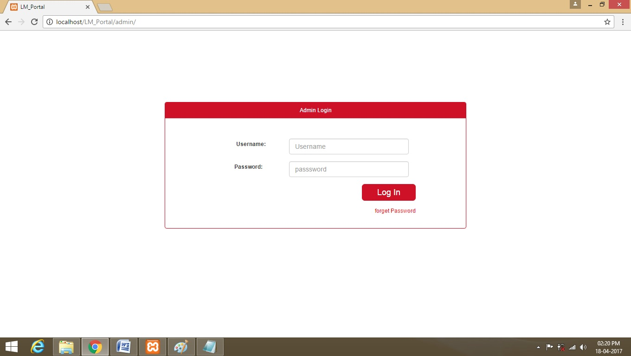

**Employee Registration:**

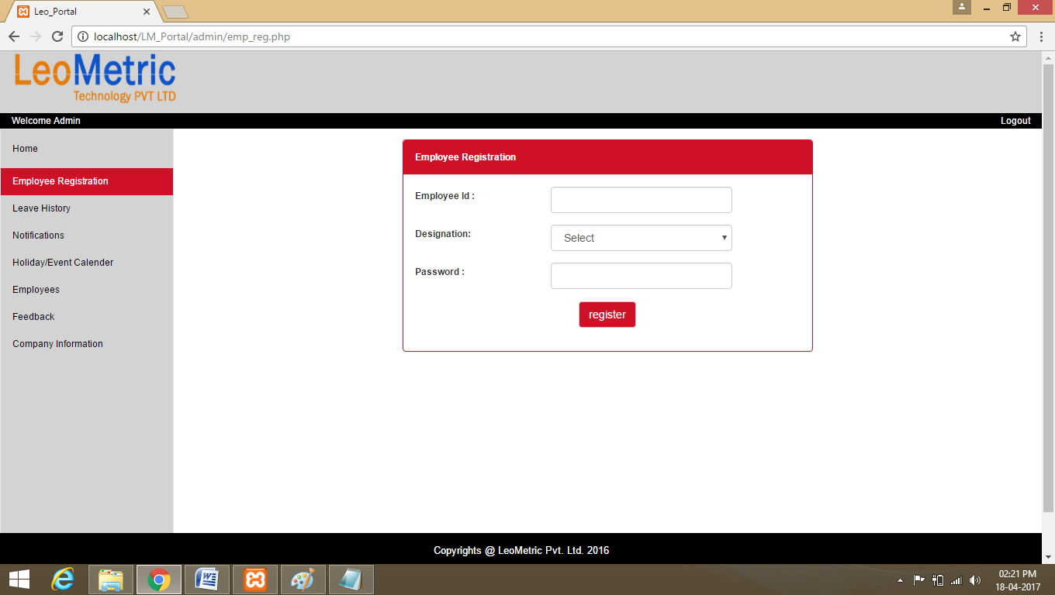

**Holiday Calender:**

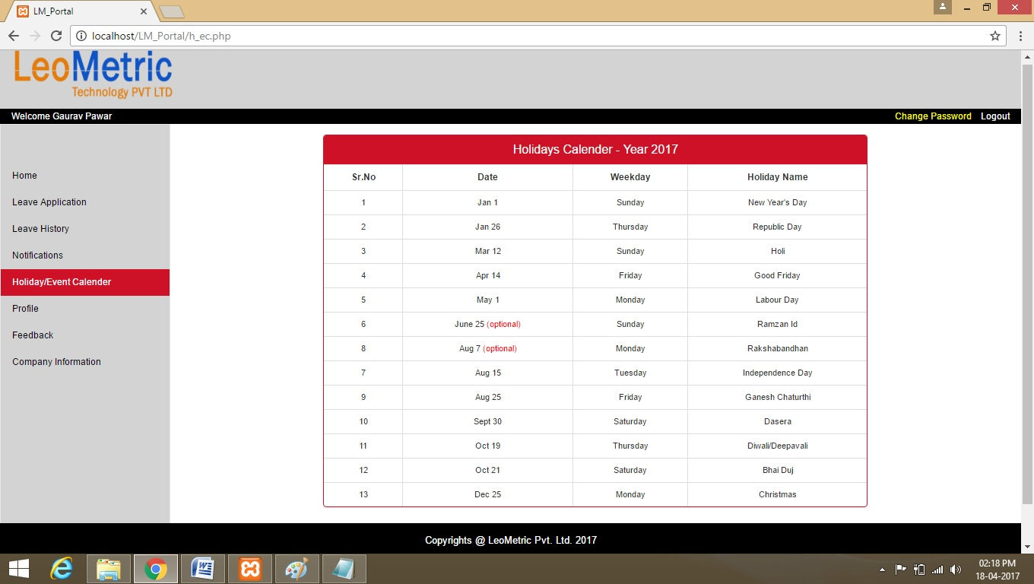

**Admin Leave History:**

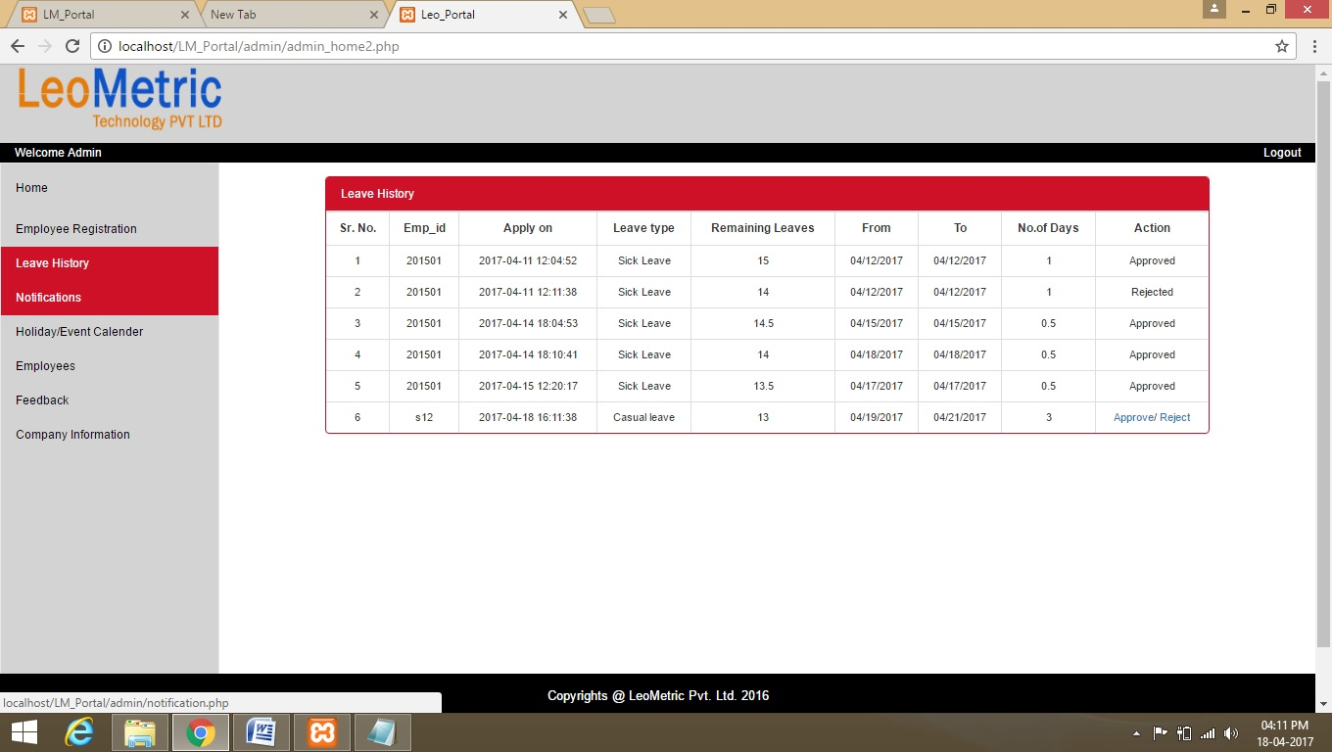

**Admin Leave History:**



**Employee Login:**

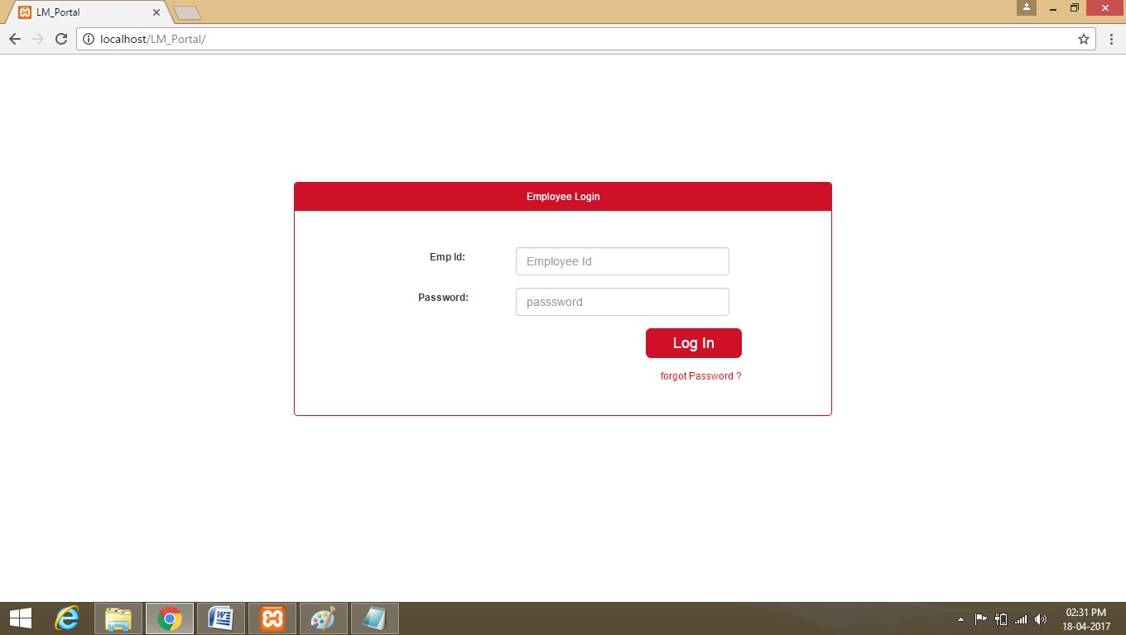

**Employee Profile:**

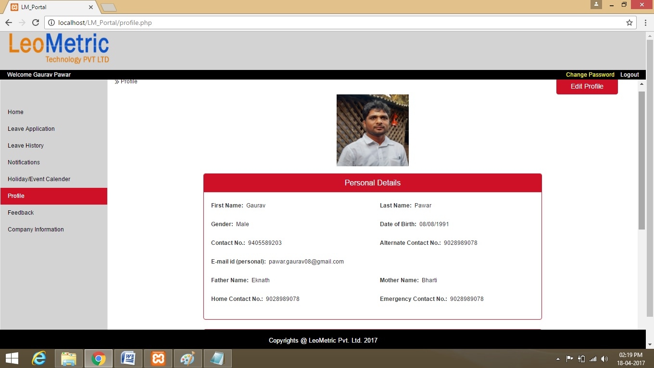

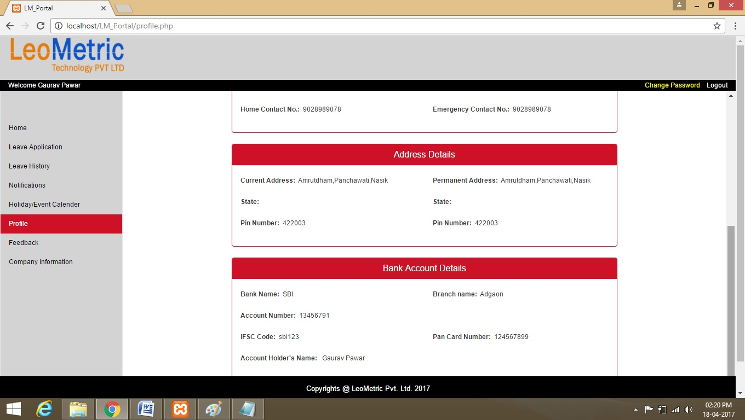

**Employee Leave Apllay:**

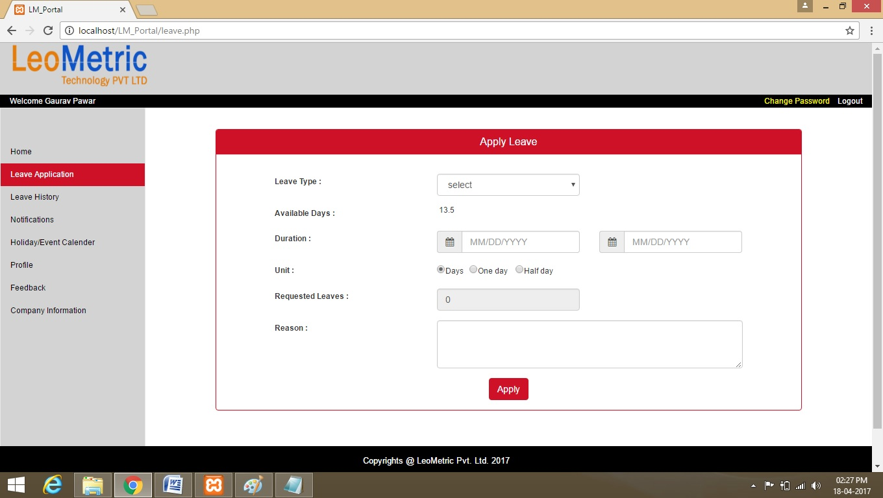

**Employee Leave History:**

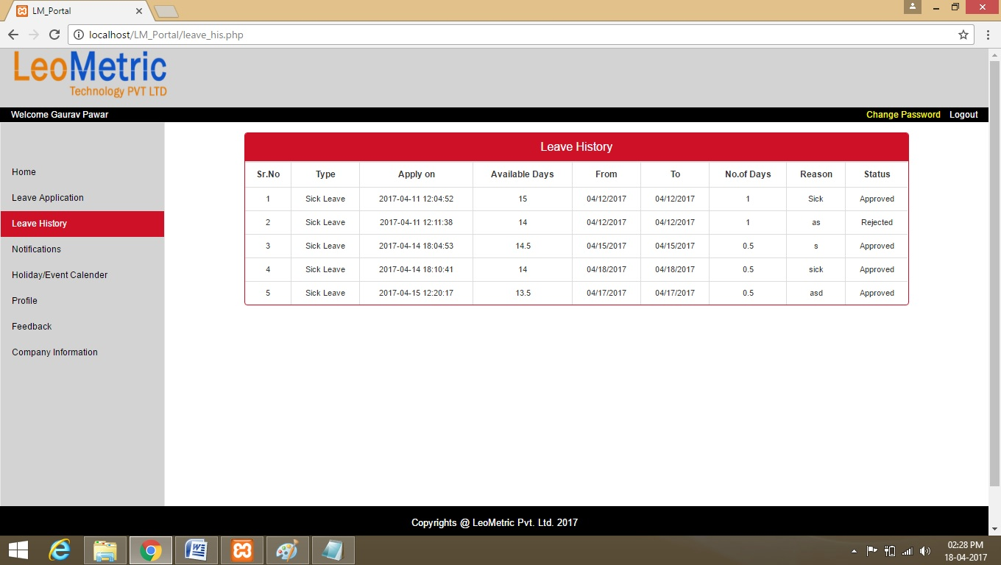

**Employee Notification:**

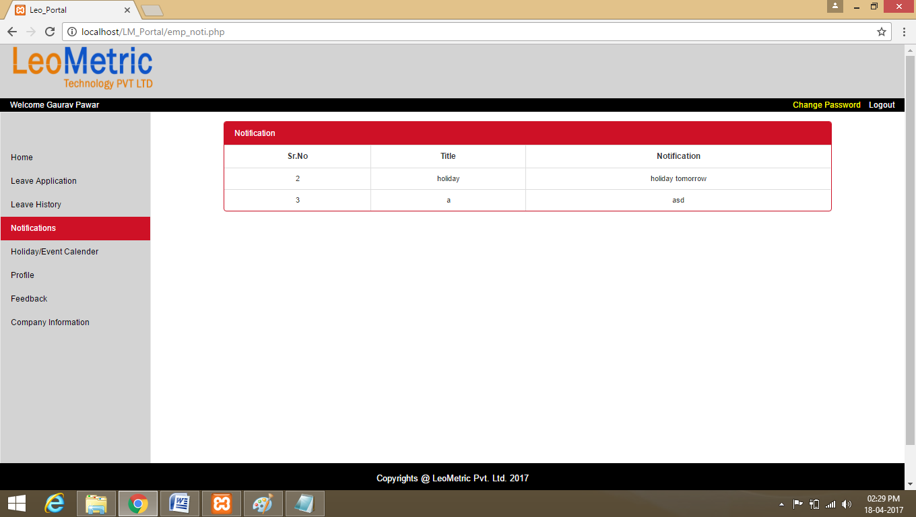

**CONCLUSION**

“LeoMetric e-leave Portal” is very easy to access from the network. It is more user friendly from other site. You also use it on smartphones because this is mobile responsive website …

**REFERENCES**

* [www.google.co.in](http://www.google.co.in)
  + PHP & MYSQL
  + Bootstrap tutorialpoint
  + Javascript ,ajax at tutorialpoint
* [www.stackoverflow.com](http://www.stackoverflow.com)
* Object Oriented Analysis, Design & Implementation by Rambaugh.